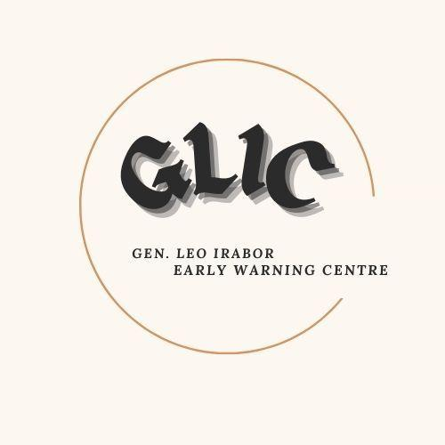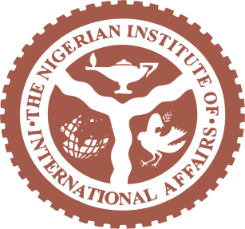

THE EARLY WARNING MONTIOR
GLIC Weekly Report 2.21

Politics

South Sudan

South Sudan orders temporary ban on social media over violence in neighboring Sudan

South Sudanese authorities on Wednesday ordered telecoms to block access to social media for at least 30 days, citing concerns over the dissemination of graphic content relating to the ongoing violence against South Sudanese in neighbouring Sudan. The temporary ban, which could be extended to up to 90 days, will come into force at midnight Thursday, according to a directive from the National Communication Authority, NCA, to telecom companies stressing that the measure was necessary to protect the public.

African News: South Sudan orders temporary ban on social media over violence in neighboring Sudan January 23rd 2024.

Violence
South Sudan

South Sudanese police impose nationwide nighttime curfew after deadly riots

Police in South Sudan imposed a nationwide nighttime curfew from Friday, a day after deadly rioting in the capital, Juba. Three people were killed and seven others were wounded in protests late on Thursday when youths attacked shops owned by Sudanese. Security forces said they had fired warning shots to stop the pillaging of the shops as the unrest spread in Juba, as well as in the towns in other parts of the country. The riots followed reports of the alleged killing of 29 South Sudanese citizens earlier in the week in neighbouring Sudan by the army and allied groups.
African News: South Sudanese police impose nationwide nighttime curfew January 18th 2024

Conflict

Sudan

UN: over one million displaced as Sudan's conflict continues

Over a million individuals have escaped the conflict in Sudan, seeking safety in neighbouring South Sudan, as reported by the United Nations. In its most recent update on this significant displacement crisis, the UN revealed on Tuesday that over 770,000 people have crossed through the Joda border point on South Sudan's northern frontier with Sudan in the past 21 months. Additionally, tens of thousands have entered through various other locations, pushing the total number of those who have fled to South Sudan since the outbreak of hostilities between the paramilitary Rapid Support Forces (RSF) and the Sudanese Armed Forces (SAF) in April 2023 to over a million, according to a statement from the UN High Commissioner for Refugees (UNHCR) and the International Organization for Migration (IOM).

African News: over one million displaced as Sudan's conflict continues January 23, 2025

Midetrranea
Italy/Libyan
Outrage in Italy over release of Libyan warlord due to legal error
Human rights organizations and opposition lawmakers in Italy expressed their anger on Wednesday after the country released a Libyan warlord due to a legal technicality. This decision came after he was detained under an International Criminal Court warrant that accused him of war crimes and crimes against humanity. Italian Justice Minister Carlo Nordio faced tough questions regarding the release of Ossama Anjiem, also known as Ossama al-Masri, who leads the Tripoli branch of the Reform and Rehabilitation Institution, a notorious network of detention centers operated by the government-supported Special Defence Force.

African News: Outrage in Italy over release of Libyan warlord due to legal error January 23, 2025

Mining

Ghana

As gold prices surge, Ghana faces ‘looming crisis’ over illegal mining
As illegal and small-scale mining contaminates rivers and soil, many worry President John Mahama will allow such practices to continue. Ghana is bending under pressure from widespread, incessant small-scale mining of the shiny metal. Much of that artisanal activity falls under what locals call “galamsey”, or in full “gather them and sell”. The term once referred to illegal mining, carried out by mostly untrained young men and women, but now more loosely encompasses licensed small-scale operations that mine unsustainably.

Aljazeera: gold prices surge, Ghana faces ‘looming crisis’ over illegal mining January 22nd, 2024.

Conflict
Congo

M23 rebels seize key eastern DRC town of Minova
M23 rebels have seized the town of Minova in eastern DR Congo, a key supply route for the provincial capital Goma, authorities said. The provincial governor of South Kivu, Jean-Jacques Purusi, on Tuesday confirmed the capture of Minova, adding that the rebels have also captured the mining towns of Lumbishi, Numbi and Shanje in the same province, as well as the town of Bweremana in neighbouring North Kivu province.

Aljazeera: M23 rebels seize key eastern DRC town of Minova January 21st 2024.

Politics
Sahel

Niger, Burkina Faso, Mali to Deploy Joint Force to Combat Security Threats
West Africa’s junta-led nations – Niger, Burkina Faso, and Mali – are set to deploy a 5,000- strong joint force to address escalating security challenges in the central Sahel region. According to Niger’s Defense Minister Salifou Mody, the Alliance of Sahel States (AES) force, equipped with air assets, intelligence resources, and equipment, will soon commence operations across the three nations. This initiative follows the countries’ decision to sever ties with Western powers and the Economic Community of West African States (ECOWAS) after they each fell to a series of coups between 2020 and 2023. The Sahel region has been battling with Islamist insurgencies linked to Al Qaeda and ISIS for about a decade. The crisis has only worsened since the coups, despite promises to tackle them.

iAfrica: Niger, Burkina Faso, Mali to Deploy Joint Force to Combat Security Threats January 23,
2025

West Africa
Togo

Togo Considering Becoming a Member of the Alliance of Sahel States
Togo is exploring the possibility of joining the Alliance of Sahel States (AES), according to Foreign Minister Robert Dussey. Dussey emphasized that the decision lies with the President of Togo but suggested public sentiment would likely favor the move. Membership in the AES could provide strategic benefits, granting the landlocked member states—Mali, Niger, and Burkina Faso—access to the sea via Togo’s coastline and the port of Lomé, boosting regional trade. Such an arrangement would benefit Togo, which would serve as the hub of commerce. The AES was formed by these military-led nations after their withdrawal from ECOWAS, citing alleged manipulation by France, their former colonial power.

iAfrica: Togo Considering Becoming a Member of the Alliance of Sahel States January 23, 2025

Public Health
United States
The US withdrawal from the WHO: a global health crisis in the making
In a major blow to global health, the US administration has announced plans to withdraw from the World Health Organization. Kent Buse and colleagues propose urgent actions for the international community to mitigate the damage. When the previous Trump administration announced its withdrawal from the World Health Organization (WHO), the decision sent shockwaves throughout the world. While that decision was reversed by the incoming Biden administration, Trump has done it again. And this time around, he has sufficient time to complete the 12-month withdrawal process. This severing of ties between the world’s largest economy and its foremost public health body represents a major setback for health diplomacy, scientific collaboration, and funding. The repercussions will ripple across borders, leaving WHO weaker and the US isolated when global health challenges demand unity.

BNJ: The US withdrawal from the WHO: a global health crisis in the making January 21, 2025

Public Health
Nigeria

Contagious Skin Disease Plagues Borno’s Displaced Community for Over a Year
There is an alarming health crisis in the Low-Cost displacement camp in Damboa town, Borno state, northeastern Nigeria. The camp was established nearly a decade ago, following the terrorization of several communities in the region by terrorists. It now shelters about 1,500 households, comprising more than 7,000 displaced people who fled from over four remote communities in the area. For over a year, the camp has been plagued by a widespread, contagious skin disease. Despite several attempts to treat the outbreak with traditional and modern medicine, no cure has been found. Day by day, the epidemic continues to spread across the camp, leaving a trail of suffering in its wake.

Human Angel: Contagious Skin Disease Plagues Borno’s Displaced Community For Over a Year January 21, 2025

Public Heath
Tanzania

Tanzania confirms outbreak of Marburg virus
Tanzania’s President SamiaSuluhu Hassan on Monday confirmed an outbreak of the Marburg virus in the country, with one confirmed case so far. “Laboratory tests conducted at Kabaile Mobile Laboratory in Kagera and later confirmed in Dar es Salaam, identified one patient as being infected by Marburg virus,” she said at a press conference that was also attended by World Health Organization (WHO) Director General Tedros Adhanom Ghebreyesus in Dodoma, the capital city in the centre of the country. Victims had presented with typical Marburg symptoms, including headache, high fever, back pain, diarrhea, vomiting blood, muscle weakness and external bleeding.
The East African: Tanzania confirms outbreak of Marburg virus January 20, 2025

Public Health
Zimbabwe

Zimbabwe cholera outbreak spreads to eight districts
Zimbabwe’s ministry of health and child care has announce that the current cholera outbreak in the country has affected the districts of Bikita, Bindura, Chiredzi, Chipinge, Kariba, Goromonzi, Mazowe and Shamva. The farming town Glendale in the Mazowe district, located about 70 kilometers north of Harare, is one of the epicenters of the outbreak. Residents there are appealing to the government to take urgent action to end the spread of the disease. Glendale residents are being forced to navigate pools of sludge after the government left burst pipes neglected for months. Human waste carrying disease agents have apparently been contaminating freshwater sources in Glendale and beyond.
Mail and Guardian: Zimbabwe cholera outbreak spreads to eight districts January 20, 2025

Environment
West Africa & Sahel

Rescuing the Lake Chad: A Call to urgent action on an existential problem (5), by Usman Sarki
“Nigeria faces serious environmental challenges, including deforestation, desertification, coastal erosion, flooding, pollution and many other negative impacts of climate change. Lake Chad continues to shrink every year. These issues threaten the livelihoods of millions of Nigerians”— President Bola Ahmed Tinubu.In this final installment in the series of articles on the Lake Chad, it is my intention to urge that all stakeholdersshould note this dire warning by President Tinubu, particularly with regards to the Lake Chad and its significance not only for Nigeria, but for the rest of the countries that border the Lake.
Vanguard: Rescuing the Lake Chad: A Call to urgent action on an existential problem (5), by Usman Sarki January 22, 2025

