TUESDAY TEA IS BACK!
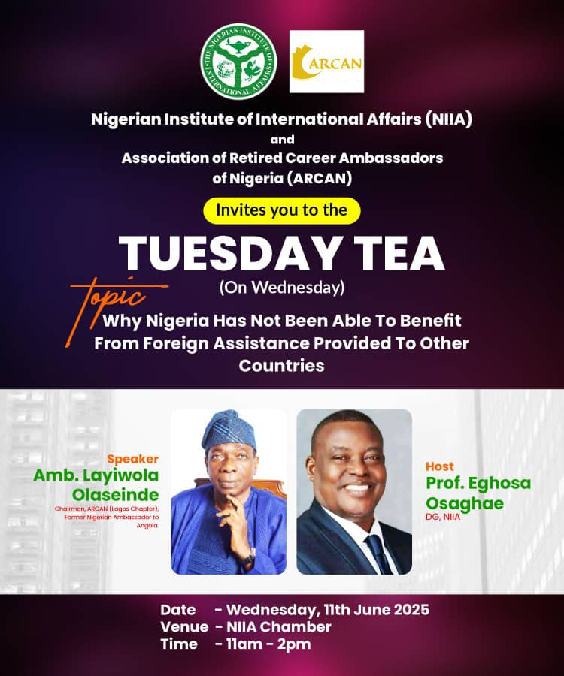
“Why Nigeria has not been able to benefit from foreign assistance provided to other countries.”- Ambassador Layiwola Olaseinde, Chairman, ARCAN.
An old culture was revived on Wednesday, 11 June 2025, when the Nigerian Institute of International Affairs (NIIA) and the Association of Retired Career Ambassadors of Nigeria (ARCAN) held the Tuesday Tea- a lecture and interactive discussion led by retired ambassadors for research fellows, other members of the Institute and interested members of the general public. The title of the lecture, the first in a long time, was, “Why Nigeria has not been able to benefit from foreign assistance provided to other countries.” The lecture was delivered by Ambassador Layiwola Olaseinde, Chairman of ARCAN and former Nigerian Ambassador to Angola and it was graciously attended by other former ambassadors such as Ambassadors Adenike Ukonga, Oluwole Coker and Afolabi Adefidipe.
The lecture chaired by distinguished Professor Femi Otubanjo, a Research Professor at the Institute, was a historic gathering being the first event following the memorable re-enactment of the ECOWAS Treaty and the ECOWAS @50 celebration that were hosted by the Institute on 28 May 2025.
The lecture was an expository, enlightening and mind-boggling session as Amb. Layiwola Olaseinde narrated some of his experiences about Nigeria and her external relations, primarily focusing on the reasons Nigeria had not benefited from the numerous goodwill gestures and activities with other African countries. He mentioned instances where Nigeria sent troops to countries in distress unsolicited and especially the material assistance rendered to Angola despite all the intrigues involved. Unfortunately, several of the assistance, financial, material and other forms, were undocumented. He cited examples of nations assisted by Nigeria such as Zambia, Zimbabwe, Mozambique, South Africa and Angola. One of the foreign assistance was rendered through the Technical Aid Corps (TAC) established by Professor Bolaji Akinyemi in 1987 during the military regime of President Ibrahim Babangida, when he was the Minister of foreign affairs.
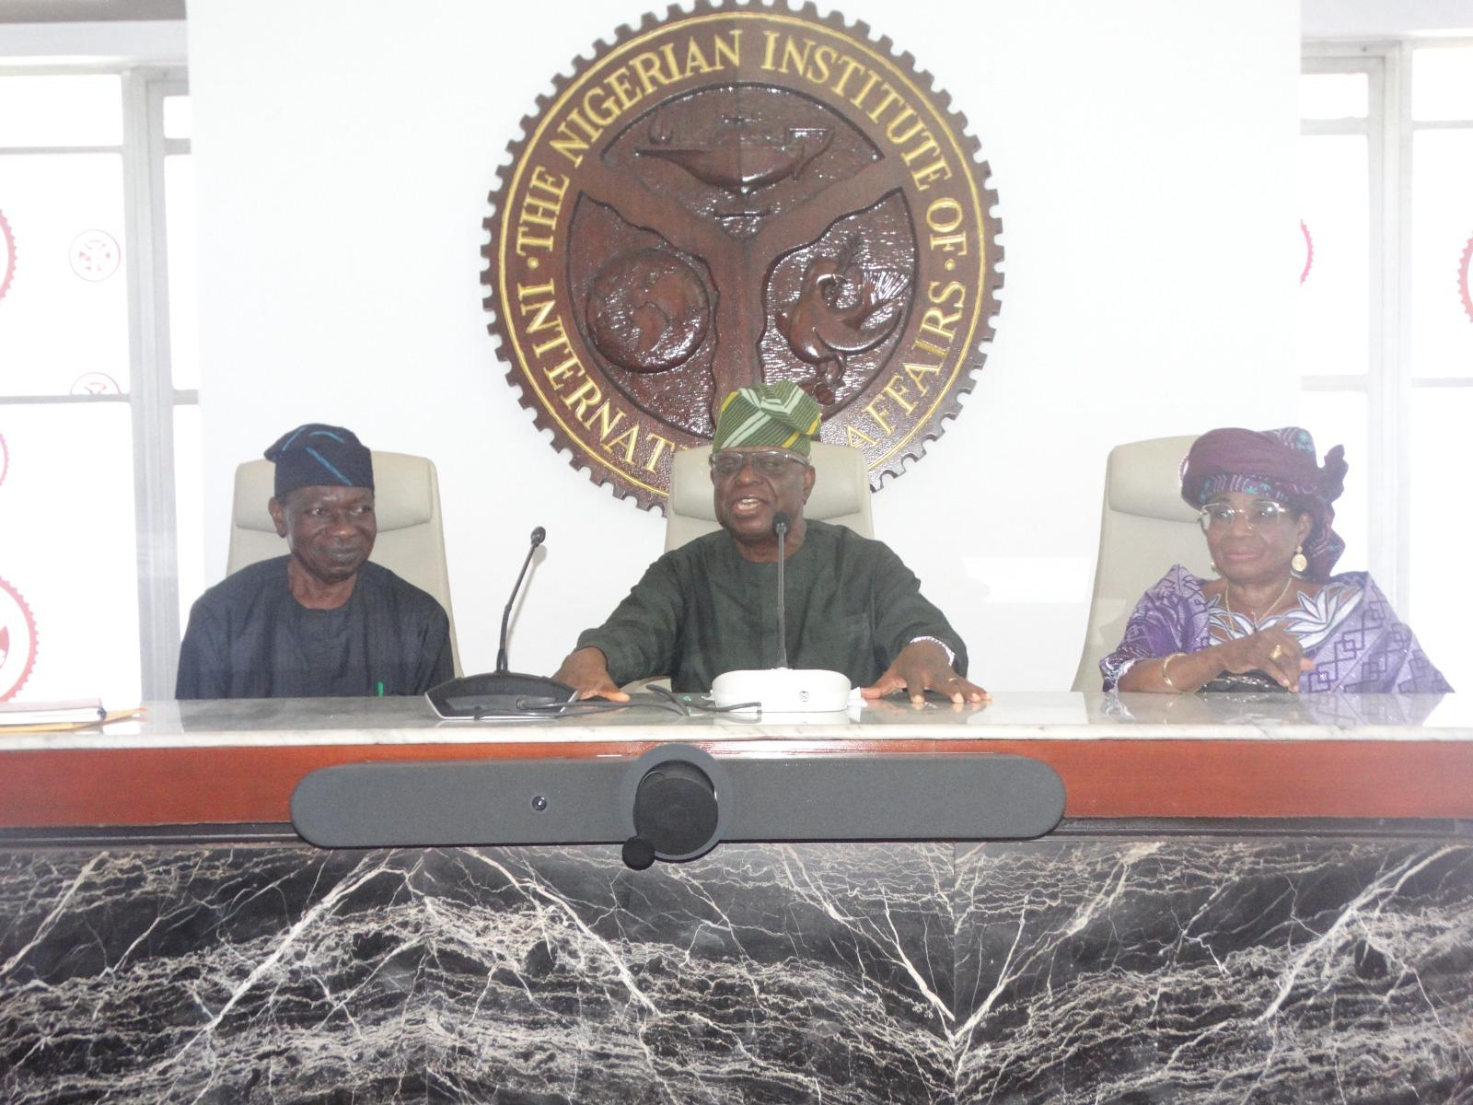
The lecturer noted that the United States of America, in all its means of foreign assistance to other nations always have an ulterior motive, though usually focused on their goals. For instance, America wants to perpetuate its position in the global arena as the most powerful and superior while Nigeria is only interested in rendering humanitarian assistance without any hidden motive. The US, in decades back, was also interested in countering the Soviet Union and communist ideologies, while dictating policies to the rest of the world.
In response to the question, “Why does Nigeria give foreign assistance?”, Ambassador Olaseinde enumerated some points as factors responsible for Nigeria’s stance towards foreign assistance. Nigeria takes pride in lending financial, military, and other forms of support to African countries. African countries made requests from Nigeria when they were threatened and almost over-run by rebels and as against the system used by the US, Nigeria has never been interested in controlling other nations.
About the reasons alluded to the question of Nigeria not benefiting from other nations, the speaker explained that in foreign policy and politics, culture is downplayed, while the culture of brotherhood, which is prevalent in Africa is exalted. Another important note given is that, since most texts are written by foreign scholars and writers, the true and full content of Nigeria’s efforts towards the other African countries may not be captured the way an indigenous scholar would. Amb. Olaseinde quickly used the moment to encourage and spur research fellows to take up the bid and adventure to document Nigeria’s history the most appropriate way, thereby decolonizing their thoughts. He stated also that Nigeria has no ideology pitiably, aside the fact the African states Nigeria helped had no capacity to pay back since they are third world countries (TWCs). This meant that Nigeria and these other African states are on the same category-TWCs. Apart from Nigeria not having any vested interests in benefiting countries, it was also very discreet when giving financial aid and so, no records were kept.
The lecture was followed by an interactive session as research fellows raised questions on diverse issues stemming from the lecture. Assoc. Prof. Joshua Bolarinwa, the Acting Director of Research at the Institute asked if the law of reciprocity should be adopted considering the unfair treatment Nigeria has been given especially from nations that had benefited from Nigeria’s largesse and generosity. Mr. Mayowa Albert, a research fellow wondered if Nigeria could lean towards the socialist ideologies of Russia and China, while Mr. Uche Nwali enquired if Nigeria should continue with her method of giving aids without interests. Dr. Tola Ilesanmi, a senior research fellow sought answers to the question of if Nigeria should continue her altruistic approach in their relations with other African states. Dr. Esther Idowu, another research fellow pondered on the reasons for the dearth of documentation at that period especially during General Murtala Mohammed’s regime. Ms. Ebuwa Osarenren wanted to know if Nigeria could leverage the relations established in the past to put herself on the world stage in order to build relevance.
In response, Amb. Olaseinde revealed that the capacity of the beneficiaries of Nigeria’s goodwill was shallow and may not be able to pay back and the differences in ideologies counted for something. He clarified that to have an effective democracy, there are bedrocks and institutions that must be functional. Some of the examples mentioned were the press, law enforcement agencies, and the judiciary. He concluded that Nigeria lacks the ingredients for democracy.
Contributions were also made by other ambassadors to the discourse on documentation and record keeping issues in Nigeria. Amb. Adenike Ukonga disagreed with the claim that Nigeria’s culture of brotherhood was responsible for the absence of records. She, however, called for respect for Nigeria among African nations for the numerous efforts Nigeria has put in for them. She also advocated that Nigeria should put some conditions on her assistance for other nations henceforth. Amb. Oluwole Coker agreed to asking for a recompense from the nations that have benefited from Nigeria while encouraging Nigeria to always amplify such assistance. He asserted that non-documentation of humanitarian assistance rendered amounted to robbery and corruption and before Nigeria thinks of launching to the global arena, she must have a cohesive plan. He stated too that NIIA Research Department should state clearly to members of ARCAN what they want them to do in terms of knowledge and experience sharing. Finally, he charged NIIA to seek funding for research targeted at documentation from the private sector. Amb. Afolabi Adefidipe agreed with Amb. Coker that NIIA should look into funding for documentation research.
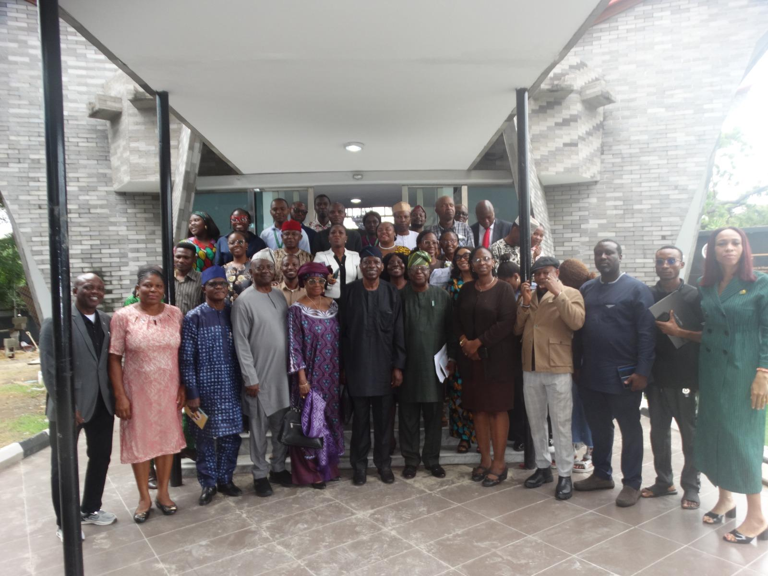
In his closing remarks, Prof. Femi Otubanjo emphasized the essence of documentation, stating that bridging the documentation gap requires culture and ideology because they play a huge role. The lecture wrapped with a group photograph and a tea break.
Compiled by NIIA Report Writing Team

