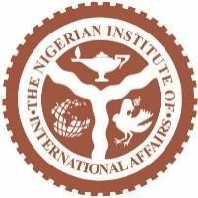

Election in Africa and the transition of Power from incumbent to opposition
GLIC Commentary by Igwe Kelechi Njoku
October 3, 2025.
Introduction
The increasing trend of African states incumbent Heads of Government conceding electoral defeat at competitive elections to opposition candidates defies Africa's democratic backslide as democracy is challenged across the globe. From Nigeria to Malawi, the Gambia, Ghana, Madagascar and several other state’s incumbent leaders have been defeated as they sought to renew their terms in office in recent years. The transfer of power from incumbents to opposition parties now appears common in some democratic states with an institutionalised party system. By contrast, African states with a weakly institutionalised party system conduct elections in an atmosphere characterised by exclusion, intimidation and violence. However, summing up the elections held in 2024 across Africa, there are some progressive strides.
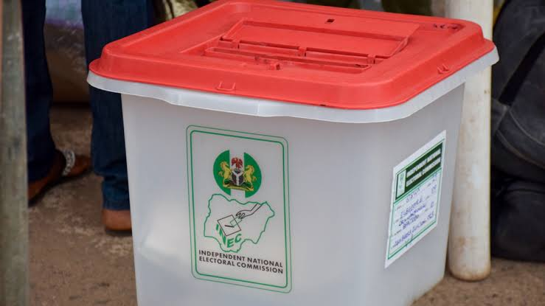
Ballot box used for voting
Five democracies; Botswana, Ghana, Senegal, Somaliland and Mauritius held elections that ended with incumbent presidents handing over power peacefully to successful opposition candidates. South Africa witnessed the end of three decades of single-party rule. Altogether, these six elections show proof of democratic resilience in Africa and bring hope of a trend reversal.
2024 African elections in a glance
National elections were planned in 19 African states in 2024. Some of those were, however, postponed due to security concerns in the Sahel. Africa in the end of 2024 recorded five relatively peaceful transfers of power – a significant achievement for Africa’s democratic growth. Political parties offer meaningful opposition when they mobilise dissatisfied voters to replace the government through the ballot box. And the presidential and parliamentary elections in Senegal, Botswana, Mauritius, Somaliland and Ghana saw opposition parties do just that. In South Africa, the ruling ANC party was humbled when it lost its dominance for the first time in 30 years: it was forced to form a coalition with other, smaller parties. Elsewhere, citizens voted out governing parties that threatened democracy, punishing governing parties such as the Botswana Democratic Party (BDP) and Ghana’s New Patriotic Party (NPP) in national elections in October and December. On the other hand, in elections in Algeria, Tunisia, Chad and Mozambique, the governing parties failed to fulfill essential democratic functions and circumvented electoral accountability. The victory of the governing party SWAPO in Namibia was marred by massive electoral flaws. Nevertheless, Namibia made history when it elected its first female president.
Trajectory of Incumbent transition of Political Power
The latest African Incumbent leader to transit Political Power is Malawi’s President Lazarus Chakwera who lost to his predecessor, 85-year-old Peter Mutharika in the country’s September 16 2025, elections. In sporting terms, this is an equalizer because Chakwera came to power in 2020 after defeating Mutharika, who was the incumbent at that time, Mutharika’s first ascension to the presidency in 2014 was also interesting having won elections against then –incumbent Joyce Banda, in short, Mutharika defeated two incumbent presidents and was himself defeated once as an incumbent president.
In West Africa, Ghana another interesting political scene as it consolidated on her thriving democracy. Current President John Dramani Mahama made a rare return to power in January 2025 after winning an election against the candidate of the ruling NPP party Mahamudu Bawumia in December 2024, Mahama of the National Democratic Congress who previously served as president from 2012 to 2017 first lost the 2016 election and conceded defeat to then opposition candidate Nana Akufo-Addo who then became president. Then peaceful switch of power between rivals on both occasions helped to reinforce Ghana’s reputation as a stable democracy.
Nigeria made history in 2015 when then-incumbent President Goodluck Jonathan of the People’s Democratic Party (PDP) lost election and conceded defeat to then-opposition leader Muhammadu Buhari of All Progressive Congress (APC) a coalition of some opposition political parties. That was the first time in Nigeria’s history that a democratically elected incumbent president handed power to another democratically elected president from an opposition party.
In Liberia, African great football legend turned politician George Weah lost the 2023 elections as he sought a second term in office as president. He accepted defeat and congratulated, the winner, opposition candidate Joseph Boakai who is the current president of Liberia.
However, not all the analysis of the peaceful transfer of political power from an incumbent to opposition is unidirectional and ended with handshakes. For example, the Gambia in 2016, then President Yahya Jammeh retracted his acceptance of defeat to then opposition candidate Adama Barrow. He vowed not to hand over power to Barrow but eventually did so in absentia after the regional bloc ECOWAS intervened.
In Southern Africa, Botswna current president Duma Boko came to power after beating incumbent Mokgweetsi Masisi in the 2024 elections, ending nearly decades of the Botswana Democratic Party BDP’s rule. And in Madagascar in 2018, then-president Henry Rajaonarimampianina lost election after getting just 8.8% of the votes too little to even make it to the second round which was eventually won by Andry Rajoelina who is now in power.
Conclusion
I will assert that the increasing trend of peaceful transfer of power across Africa is a significant sign of the continent’s success in consolidating democracy amid the backslide from the unprecedented chain of coups since 2020. Elections are a critical part of Africa’s democratic system, important part of the process of deepening and institutionalizing democracy. The impeding dilemma hangs on the uncertainty if the intense competitive elections in 2025 in Cameroon, Ivory Coast and early 2026 in Uganda and South Sudan will follow this progressive trend to further consolidate democracy in Africa through peaceful transfer of power to an opposition as the incumbents desperately seeks re-elections.

Igwe Kelechi Njoku (kessiigwe@gmail.com) is with the Gen. LEO Irabor Early Warning System Centre and a Research Fellow at the Nigerian Institute of International Affairs (NIIA).

