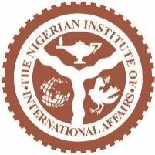
The Sudanese Conflict and Nigeria’s Pivotal Concern: A GLIC Commentary
Introduction
Sudan is the third-largest country in Africa (Adesina, 2020). It has an estimated population of 50,614,633 in 2025, which is a 2.55% increase from 2024 (Macro Trends, 2025). The state has a GDP of 109.27 billion US dollars (2023 Est. by Macro Trends, 2025). It is endowed with oil, minerals, arable land and water resources (UNECA, 2021). Located in Northeast Africa, Sudan’s geographical diversity is made up of deserts, mountains, savannas and river plains (Siddig et al, 2018).
Sudan is a Federal Republic, with a presidential system that had the executive, legislative and judicial branches of government before political interference by the military. A coup d’état in 2019 disrupted the regime of President Omar al-Bashir who had seized power in 1989 and ruled Sudan for about 30 years (Hassan & Kodouda, 2019). After the ouster of Omar al-Bashir on 11 April 2019, Sudan’s military established the Transitional Military Council (TMC) to govern the country. Initially led by Defense Minister Lt. Gen. Ahmed Awad Ibn Auf, he resigned a day later due to public rejection and then the council’s leadership passed on to Lt. Gen. Abdel Fattah al-Burhan, with Gen. Mohamed Hamdan “Hemedti” Dagalo, commander of the Rapid Support Forces (RSF), being his deputy. The TMC held power amid mass protests and negotiations with civilian groups until the August 2019 Constitutional Declaration established a joint military-civilian Sovereign Council to oversee a 39-month transition to civilian rule. Working with Sudan’s pro-democracy movements, Gen. al-Burhan became the de facto head of state while serving as the chairman of the Sovereign Council. But in 2021, Gen. al-Burhan and his second-in-command, Gen. Hemedti staged a coup and cancelled Sudan's democratic transition (Al Jazeera, 2023).
The Conflict
The Sudanese armed conflict began in April 2023 as a result of a violent power struggle between the Sudanese Armed Forces (SAF), led by General Abdel Fattah al-Burhan and the paramilitary Rapid Support Forces (RSF), led by General Mohamed Hamdan “Hemedti” Dagalo. The conflict emerged from a failed transition to civilian rule following the ousting of Omar al-Bashir and a subsequent military coup in 2021. The Sudan 2021 coup occurred on 25 October 2021, when General Abdel Fattah al-Burhan and the military dissolved the Sovereign Council, detained Prime Minister Abdalla Hamdok and civilian leaders, declared a state of emergency and suspended parts of the 2019 Constitutional Declaration (Woźniak, 2023). Triggered by tensions over reforms, power-sharing and control of security forces, the coup provoked nationwide protests demanding civilian rule, which were met with violent repression, causing many deaths and injuries. Although Hamdok was briefly reinstated under an international deal in November 2021, he resigned in January 2022, citing the military’s resistance to genuine democratic transition.
Following a failed democratic transition, tensions between SAF and RSF escalated into a brutal civil war. Generals Burhan and Hemedti, who both played key roles in Sudan’s 2003 counter-insurgency in Darfur, became rival power figures. Despite their cooperation to execute the 2021 coup d’état against President Omar al-Bashir, Burhan as head of the army and Hemedti as leader of the Rapid Support Forces (RSF) began to have complications because the RSF is a formalised version of the Janjaweed militias (Copnall, 2023). Their rivalry deepened over disagreements on integrating the RSF into the regular army, culminating in a fierce struggle for control of the Sudanese state. The conflict has caused mass displacement, widespread destruction and a dire humanitarian crisis, with peace efforts yet to succeed. It is interesting to note, that while former President Omar al-Bashir was tried for war crimes, crimes against humanity and genocide committed during the 2003 Darfur conflict, both Generals were involved in those atrocities (Copnall, 2023). President Omar al-Bashir’s government was accused of orchestrating a brutal counter-insurgency campaign against non-Arab rebel groups in Darfur, using the army and Janjaweed militias to carry out mass killings, rape, forced displacement and the destruction of villages (ICC, 2009).
Humanitarian Impacts
The conflict has been defined by several critical developments, including the repeated breakdown of ceasefires, intense clashes over control of Khartoum and widespread atrocities committed by the Rapid Support Forces (RSF) such as sexual violence and ethnically targeted killings which prompted the imposition of U.S. sanctions (CFR, 2025). The RSF’s siege of El-Fasher has heightened concerns about potential genocide, while its announcement of a parallel government in July 2025 further fragmented the political landscape (BBC News, 2024). Although the Sudanese Armed Forces (SAF) managed to regain parts of Khartoum in May 2025, the fighting continues unabated. With over 12 million people displaced and 18 million people facing acute food insecurity, the war has triggered a massive humanitarian catastrophe and drawn in external powers like Egypt, the UAE and Libya, effectively transforming the conflict into a regional proxy war (UNHCR, 2025). Meanwhile, Sudan’s hopes for a civilian-led transition have been severely undermined, plunging the country back into authoritarian turmoil.
In terms of Causalities, more than 150, 000 people have died across the country due to the conflict (BBC News, 2025). Sudan faces the world’s largest displacement crisis. Refugees have flooded into neighboring countries, while 70–80% of health facilities are non-functional amid deadly disease outbreaks and widespread malnutrition (WHO, 2025).
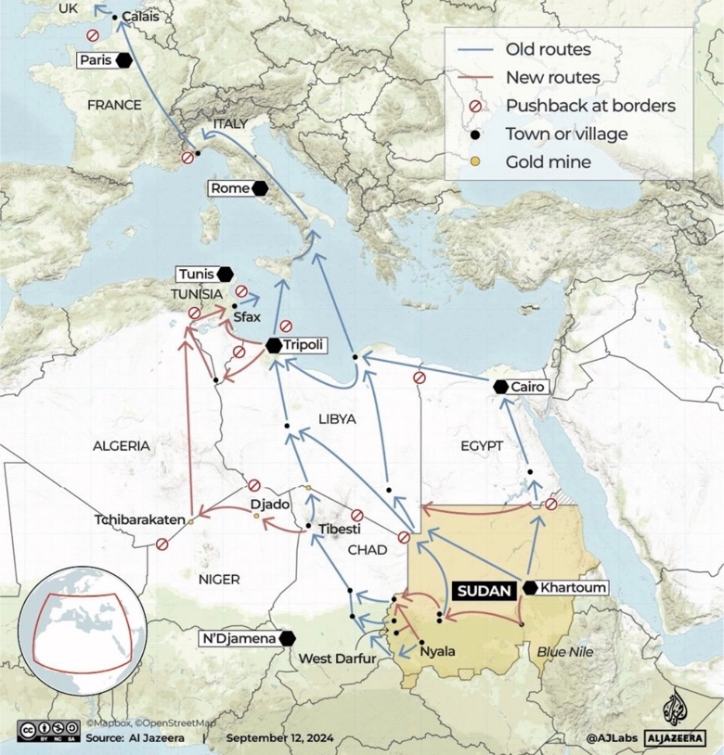
Fig. 1. Map showing the refugee flows from Sudan to other parts of the world (Aljazeera, 2025).
Children are especially affected, with millions of out of school and many recruited as child soldiers. Atrocities such as ethnic massacres, sexual violence and forced conscription have been widespread amongst the RSF. Humanitarian access also remains severely restricted, aid workers targeted, and only a fraction of relief needs funded (ACAPS, 2025). Due to the raging war, Sudan’s economy has also contracted by over 42%, with hyperinflation, unpaid salaries, and market breakdowns forcing many into poverty (IFPRI, 2025). The conflict’s spillover threatens to destabilize Chad, South Sudan, Egypt, and the broader region, as overwhelmed host countries struggle to absorb refugees and prevent cross-border violence.
Actors
- SAF (Primary Military Outfit) and RSF (Para Military): While the SAF is the Sudanese Armed Forces of the Republic of Sudan, RSF is a Sudanese paramilitary group. They emerged from the Janjaweed militias and were established around 2013. RSF has at a time or the other been active in Libya and Yemen. Beginning in 2015, the RSF deployed to Yemen as part of the Saudi and UAE-led coalition, fighting Houthi forces and supporting the internationally recognized government. In July 2019, approximately 1,000 RSF fighters were deployed to eastern Libya to support Khalifa Haftar’s Libyan National Army (LNA) in its campaign to seize Tripoli, guarding oil infrastructure and freeing LNA units for frontline operations.
- Sudan’s conflict has attracted significant international and regional involvement, with each actor pursuing distinct political, strategic, or economic interests. The United Nations and African Union have condemned the violence and pushed for humanitarian aid and a political resolution, but their efforts have been hampered by insecurity and limited access. Saudi Arabia and the United States have facilitated the Jeddah peace talks, aiming for ceasefires and humanitarian corridors, though their impact has been minimal due to persistent violations and distrust between factions.
- Multiple international and regional actors including Saudi Arabia, U.S., Russia, Egypt, UAE and IGAD have shaped Sudan’s conflict through diplomacy, mediation, or covert support. While some push for peace, others exploit the war for strategic, economic or ideological gains, fueling instability and complicating resolution efforts.
- Russia’s push for a naval base in Port Sudan deepened divisions between Sudan Generals Burhan and Hamedti, who courted Moscow for support. Burhan sought legitimacy through the naval base deal, while Hamedti used ties with Russia’s Wagner Group and gold exports to bolster his forces. This external competition increased mistrust between the Sudanese Armed Forces (SAF) and Rapid Support Forces (RSF), worsening their power struggle. Through the Wagner Group (now Africa Corps), Russia has fueled the war by backing the RSF in exchange for mining concessions, while seeking military footholds and using Sudan’s resources to support its global ambitions.
- Egypt supports the SAF to protect its southern border and Nile water interests, reinforcing Burhan’s position. In contrast, the UAE has been accused of aiding the RSF to secure influence in the Red Sea corridor and access to Sudan’s gold.
- Libya’s General Khalifa Haftar has allegedly provided arms and logistics to the RSF, further internationalizing the conflict. Meanwhile, rebel and ethnic armed groups have exploited the instability to pursue regional autonomy or resource control, deepening fragmentation in areas like Darfur, South Kordofan, and Blue Nile.
- Kenya has sought to facilitate peace negotiations between the warring factions, the Sudanese Armed Forces (SAF) and the Rapid Support Forces (RSF), and promote a return to civilian governance. Though not directly bordering Sudan, Kenya plays a role in regional humanitarian responses and hosts Sudanese refugees and asylum seekers displaced by the conflict. It also contributes to shaping humanitarian policy through the African Union and IGAD frameworks.

Resolution Efforts
Efforts to resolve Sudan’s conflict at both local and national levels have included advocacy by civil society groups, resistance committees, and women’s organizations pushing for ceasefires and humanitarian access. However, their ability to influence the Sudanese Armed Forces (SAF) and the Rapid Support Forces (RSF) remains limited. In Darfur and Kordofan, tribal leaders have managed to secure temporary local truces, but these often collapse due to breaches by the fighting parties. Political coalitions such as the Forces of Freedom and Change (FFC) have urged dialogue, though they lack real negotiating power. Mediation efforts by Islamist groups associated with former President Omar al-Bashir have deepened divisions, as they are widely mistrusted. At the regional level, IGAD’s initiatives including the Jeddah talks co-hosted by Saudi Arabia and the U.S have faltered amid boycotts and ceasefire violations. Egypt’s backing of the SAF and the UAE’s alleged support for the RSF have compromised regional neutrality and intensified Gulf rivalries. On the international front, both the UN and African Union have struggled to enforce significant actions due to global political rifts. The UN Security Council has been paralyzed by vetoes, United Nations Integrated Transition Assistance Mission in Sudan (UNITAMS) has withdrawn and sanctions from the U.S. and EU have yielded little effect.
At the 2025 United Nations General Assembly, a sideline meeting on Sudan gathered regional and international actors, including the AU, EU, IGAD and Arab League, to strengthen diplomatic efforts toward ending the conflict. The meeting reaffirmed support for a ceasefire, humanitarian access and a return to direct negotiations, while condemning foreign military interference (Defence Web, 2025). It also endorsed the “Quad” roadmap, championed by the US, Saudi Arabia, Egypt, and UAE, which proposes a three-month humanitarian truce followed by a nine-month transition to civilian-led governance (AP News, 2025).
Discussions
AU needs to come up with another strategy in Sudan. Nigeria should leverage its leadership in ECOWAS and the African Union to push for unified peace efforts, host neutral mediation talks in Abuja and discourage external military involvement by pressuring regional actors like Libya, Egypt and the UAE. At the 80th UN General Assembly in New York, Nigeria’s Vice President Kashim Shettima reaffirmed Nigeria’s commitment to multilateralism, peace and human rights (Nigeria Info, 2025). He calling on the global community to renew and reform its institutions for greater relevance and fairness. He emphasized the importance of sovereign debt relief, equitable access to trade and finance, the need for countries to benefit from their natural resources and the urgency of closing the digital divide. Though he spoke broadly on global challenges, his remarks implicitly expressed solidarity with victims of conflict, including Sudan. He urged the defense of human life against violence and the revival of diplomatic pathways for peace.
Nigeria can also use the UN platform to press for an arms embargo. Nigeria can identify, name and shame the spoilers of the peace in Sudan. Nigeria can offer temporary refuge to vulnerable Sudanese populations and partner with international agencies for aid delivery to vulnerable communities in the country. The African Giant can also share intelligence on mercenary movements and prepare for potential peacekeeping deployment. By forming alliances with other African nations and amplifying civil society voices, Nigeria can promote inclusive peacebuilding. Despite internal challenges, its diplomatic experience positions it to lead African-led solutions focused on civilian protection and long-term stability.
Conclusion
From Gaza to Ukraine, the Sahel to Sudan, and across Haiti and Myanmar, conflicts rage, displacement soars, and international law is routinely violated without consequence. While diplomacy has not always prevented violence, it remains essential to ending it. Nigeria must intensify engagement with Sudan and regional actors to help resolve the crisis and support displaced populations. At the continental level, Nigeria should champion the full enforcement of the African Union’s governance frameworks and the Lomé Declaration complemented by Agenda 2063 which promote democracy, rule of law and human rights. These instruments are strong on paper but often falter in practice due to weak enforcement and political inertia. Equally vital is the AU’s Principle of Non-Indifference, which authorizes intervention in cases of atrocities and unconstitutional rule. Though inconsistently applied, it remains a powerful tool one Nigeria must push to strengthen through fair, consistent, and well-resourced implementation. In a world where impunity thrives, Nigeria must not just participate it must lead with conviction.

Disclaimer: While we strive to ensure accuracy, the content may not reflect the most current developments or research. The views expressed are those of the author and do not necessarily represent the views of the Nigerian Institute of International Affairs (NIIA).

Author: Olumayowa Albert is a Research Fellow at the Gen. LEO Irabor Early Warning Systems Centre, Nigerian Institute of International Affairs (NIIA), Lagos, Nigeria. His research interests can be found at the intersection between governance and security in Africa.

