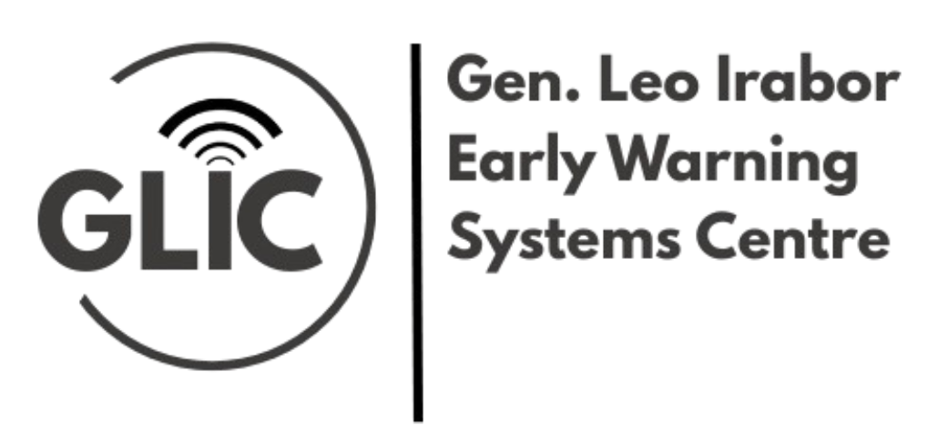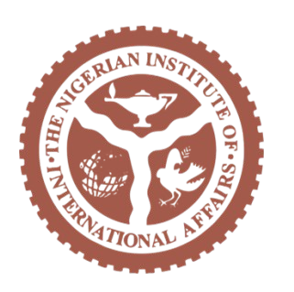

The Early Warning Monitor
GLIC Weekly Report

21st November, 2025

Top of the Agenda

CONGRESSMAN MOORE MEETS WITH DELEGATION OF SENIOR NIGERIAN OFFICIALS REGARDING THE PERSECUTION OF CHRISTIANS AND TERRORISM THREAT IN NIGERIA
Congressman Riley M. Moore met in Washington, D.C. with a high-level Nigerian delegation led by National Security Adviser Nuhu Ribadu to discuss Christian persecution and terrorist violence in Nigeria. Nigerian officials outlined challenges in counterterrorism, security assistance, and protecting vulnerable communities. Moore reaffirmed that the U.S. is ready to cooperate but insists on tangible steps to protect Christians, stressing President Trump’s firm stance against religious persecution. He emphasized joint efforts to combat Boko Haram, ISWAP, and Fulani militants and urged Nigeria to strengthen cooperation with the U.S. The delegation included senior security, foreign affairs, defence, and diplomatic officials.
Riley Moore Press Release: Congressman Moore Meets With Delegation of Senior Nigerian Officials Regarding the Persecution of Christians and Terrorism Threat in Nigeria. November 19th, 2025.

Analysis
While there is no doubt that Nigeria needs the United States on their security concerns, the manner and approach of the United States’ intervention will determine a lot in the future of US - Africa relations. President Trump had signaled an intervention with guns ablazing, but it would be very important for both states to coordinate a strategic response with respect for international law. While the United States had complained that the Nigerian government had not properly engaged the United States on the subject, it is relieving that Nigeria's National Security Adviser, Minister of State for Foreign Affairs, the Attorney General of the Federation and other Nigerian delegates visited Washington DC to discuss the possibilities of US assistance. While areas of intervention are being considered, we recommend that the Nigerian government should pay enough attention to the advisory provided by Ms. Oge Onubogu during her testimony at the congressional hearing of the US House of Representatives subcommittee on Nigeria.

Her recommendations called for a deeper, long-term U.S. engagement with Nigeria that recognizes the complex, non-religious roots of Nigeria’s security dynamics. The U.S. should work with Nigerian communities, support state-level initiatives, empower democratic and religious actors, prioritize accountability, avoid reactive policies, and revive the congressional caucus in Nigeria. For Nigeria, federal–state coordination of security responsibilities, genuine police reform, strengthened accountability, and preparations for credible 2027 elections are essential to stabilise the polity going forward. Nigeria must also appoint an ambassador to the U.S. Both countries need a fresh, realistic approach that acknowledges Nigeria’s governance challenges to effectively address conflict, insecurity, and allegations of persecution.

HIGH RISK MEDIUM RISK LOW RISK

NIGERIA

US AND NIGERIA TO FORM TASK FORCE ON CHRISTIAN PERSECUTION ALLEGATIONS
The United States plans to work with the Nigerian government to establish a joint task force to address allegations of Christian persecution, a move directed by Secretary of State Marco Rubio. US official Jonathan Pratt announced this during a congressional hearing, following President Donald Trump’s redesignation of Nigeria as a “country of particular concern.” A high-level Nigerian delegation, led by NSA Nuhu Ribadu and Attorney-General Lateef Fagbemi, is in Washington for meetings with the State Department and Department of War, amid Trump’s orders to prepare for potential military action. US officials said the strategy will be diplomatic, security-focused, and economically supportive.
Nairaland: US And Nigeria To Form Task Force On Christian Persecution Allegations. November 21st, 2025.

MASS ABDUCTIONS RETURN, 145 MISSING IN FOUR DAYS
The report of 145 people being abducted in the span of four days from Kebbi, Niger, and Zamfara states signals a dangerous resurgence of insecurity in the country. This raises concerns on how well the government is able to protect its citizens, a major issue heading into upcoming elections, where voters demand accountability and stronger safety measures. Previously, electoral campaigns have been focused on promises to reduce insecurity, but many of those promises remained unfulfilled. With national elections approaching in 2027, political leaders must demonstrate solid security solutions and restore confidence that the government can indeed prevent large-scale humanitarian crisis.
Punch News: Mass abductions return, 145 missing in four days. November 18th, 2025.

NIGERIAN CHILDREN EXPOSED TO CLIMATE CHANGE THREATS, SAYS UNICEF
A new UNICEF report, The Nigerian Child 2025, warns that Nigeria is among the world’s riskiest countries for children facing climate threats yet remains one of the least prepared. Floods, droughts, desertification and extreme heat are intensifying, while systemic gaps in infrastructure, policy and emergency response leave children highly vulnerable. Climate pressures worsen malnutrition, illness and school disruptions, and Nigeria records the world’s highest pneumonia deaths from pollution among children under five. Poor access to clean water and sanitation further exposes millions to disease. Children from low-income families and girls are most affected, with schools and health facilities lacking basic WASH services.
Punch News: Nigerian Children exposed to Climate Change Threats, says UNICEF. November 17th, 2025.

TERRORISTS INVADE CATHOLIC SCHOOL IN NIGER STATE, KIDNAP DOZENS OF STUDENTS FIVE DAYS AFTER KEBBI ATTACK
Terrorists attacked St. Mary’s Papiri Private Catholic Secondary School in Agwara LGA, Niger State, early Friday, abducting an unconfirmed number of students and teachers. Local officials and community members confirmed the coordinated assault, which occurred between 2:00 a.m. and 3:00 a.m., though reported figures—ranging from “more than a dozen” to over 100—remain unverified. Security agencies have not released an official statement. The incident follows a similar attack five days earlier on Maga Comprehensive Girls’ Secondary School in Kebbi State, where about 25 students were abducted and one staff member killed, and another recent attack in Kwara that left two security operatives dead.
Sahara Reporters: Terrorists Invade Catholic School In Niger State, Kidnap Dozens Of Students Five Days After Kebbi Attack. November 21st, 2025.

NIGERIA RANKS 8TH OUT OF 193 COUNTRIES IN THE GLOBAL ORGANIZED CRIME INDEX
Nigeria ranks 8th out of 193 countries in the global organized crime index (2025): Here are the first 15 countries.1. Myanmar 2. Colombia 3. Mexico 4. Ecuador 5. Paraguay 6. DR Congo 7. South Africa 8. Nigeria 9. Lebanon 10. Turkey 11. Kenya 12. Iraq 13. Honduras 14. Brazil 15. Libya
Nairaland: Nigeria Ranks 8th Out Of 193 Countries In The Global Organized Crime Index. November 21st, 2025.

NNAMDI KANU'S SENTENCING: LIFE IMPRISONMENT (NOT IN KUJE), NO DIGITAL DEVICE
The infamous leader of the proscribed Independent People of Biafra (IPOB), Mazi Nnamdi Kanu has finally been handed a sentence at the Federal high court sitting in Abuja. Justice James Omotoso ruled that Nnamdi Kanu must be held in a secure facility suitable for his custody, stating that Kuje Correctional Centre is not viable. He must not have access to digital devices unless monitored by the Office of the National Security Adviser. The judge ordered that Kanu be kept in protective custody in any appropriate correctional centre nationwide and directed that his transmitter be handed over to the federal government. The court imposed life imprisonment for counts 1, 4, 5, and 6; 20 years without fine for count 3; and 5 years without fine for count 7, with all terms running concurrently.
Vanguard News: Nnamdi Kanu's Sentencing: Life Imprisonment (not In Kuje), No Digital Device. November 21st, 2025.

AFRICA

ELIMINATING CERVICAL CANCER IN AFRICA – DR ISSIMOUHA DILLÉ EXPLAINS WHY AFRICA CAN WIN
On Cervical Cancer Elimination Day of Action, Dr Issimouha Dillé, WHO Africa’s Adviser on Cancer Control, emphasized that cervical cancer — despite being largely preventable — continues to pose a major public-health challenge in Africa. She argued that with strategic investments in vaccination (HPV), screening, and treatment infrastructure, African countries can make significant strides toward elimination.
WHO: Eliminating Cervical Cancer in Africa – Dr Issimouha Dillé explains why Africa can win. November 17th, 2025.

FORTY-FIVE DAYS THAT CHANGED ELECTIONS IN AFRICA?
Within a span of 45 days, several elections across Africa have displayed a worrisome decline in the legitimacy of democracy: In Malawi, former president Peter Mutharika defeated Lazarus Chakwera, reversing a previous contested outcome. In Cameroon, 92-year-old Paul Biya secured his seventh term amid accusations of illegitimacy. In Côte d’Ivoire, President Alassane Ouattara effectively ran unopposed and gave himself nearly 90% of the vote. Most alarmingly, Tanzania’s election on October 29 was marred by a harsh crackdown: under President Samia Suluhu Hassan, authorities allegedly orchestrated violence, imposed internet shutdowns, and later declared her the winner with almost 98% of the vote; many people were reportedly killed, and both the African Union and SADC rejected the results. These series of events have raised serious concerns about election fairness and political stability on the continent.
This Day News: Forty-five days that changed elections in Africa?. November 19th, 2025.

AFRICA BECOMES NEW EPICENTRE OF GLOBAL CYBER ATTACKS AS AI-DRIVEN THREATS SURGE
Africa is emerging as a major target for global cyberattacks, with AI-driven threats increasing against governments, telecoms, and critical infrastructure. Weak cyber defenses are making the region vulnerable to espionage, ransomware, data theft, and deepfake-based disinformation. These attacks pose serious risks to the government, especially during election periods, as hostile actors can manipulate information, disrupt public services, or compromise state systems. The surge in cybercrime also threatens citizen trust in digital platforms and government institutions. This trend signals rising instability, highlighting the need for stronger cybersecurity frameworks to protect governance processes, electoral integrity, and national security across African states.
Tech Africa News: Africa Becomes New Epicentre of Global Cyber Attacks as AI-Driven Threats Surge. November 21st, 2025.

THE EU SANCTIONS A SUDANESE PARAMILITARY LEADER AFTER ATROCITIES BY HIS FORCES IN DARFUR
The European Union has imposed sanctions on Abdel-Rahim Hamdan Dagalo, deputy leader of Sudan’s Rapid Support Forces (RSF), for grave atrocities committed during the two-year war with Sudan’s army, including abuses in Darfur and the recent capture of el-Fasher. Dagalo, already sanctioned by the U.S. in 2023, is held responsible for violations such as civilian targeting, ethnic killings, sexual violence, starvation tactics, and blocking humanitarian aid—acts the EU says amount to war crimes and crimes against humanity. The RSF, which now controls most of Darfur, claims to support a ceasefire. The conflict has killed at least 40,000 and displaced 12 million.
AP News: The EU sanctions a Sudanese paramilitary leader after atrocities by his forces in Darfur. November 21st, 2025.

DRC, M23 REBEL GROUP AGREE ON INITIAL FRAMEWORK FOR PEACE
The Democratic Republic of the Congo (DRC) and the Rwanda-backed M23 rebel group signed a peace agreement in Qatar aiming to end fighting in eastern DRC, where M23 has gained significant territory. Mediated by Qatar and the U.S., the deal outlines steps toward peace, including restoring government control, prisoner exchanges, and a monitoring body, but implementation remains uncertain. Past agreements failed to curb rebel entrenchment or violence. Eastern DRC faces severe humanitarian crises, with 7.8 million displaced, 28 million food-insecure, and widespread attacks by M23, the ADF, and other militias. Without robust enforcement and attention to ideological and religious factors, lasting peace remains elusive.
International Christian Concern: DRC, M23 Rebel Group Agree on Initial Framework for Peace. November 21st, 2025.

FLOODS WREAK HAVOC IN KENYAN COMMUNITIES, OVER 7,000 DISPLACED
Tourist boats on Kenya’s Lake Naivasha are now evacuating hundreds of homes as rising waters flood the Kihoto district. The lake has traveled up to 1.5 kilometers inland, submerging homes, schools, churches, and police stations, displacing an estimated 7,000 people. Residents face waist-deep water, overflowing toilets, disease risks, and dangerous wildlife encounters, while tourism and the flower industry are disrupted. Experts attribute the flooding to a combination of tectonic activity, climate change-driven rainfall, land degradation, and population pressures. Authorities have provided transport and health measures, but no financial compensation. Locals fear further destruction in the coming rainy season.
Punch News: Floods Wreak Havoc in Kenyan Communities, over 7,000 Displaced. November 19th, 2025.

THE GLOBE

HUGE STAFF CUTS AT WHO WILL LEAVE WORLD ‘LESS HEALTHY AND SAFE’, EXPERTS WARN
The WHO plans to cut over 2,300 jobs—nearly 25% of its workforce—by June 2026 due to major budget shortfalls, largely linked to the U.S. withdrawal. Experts warn these staff reductions will weaken the WHO’s capacity to respond to disease outbreaks and emergencies, particularly in low-income countries. The cuts will most heavily affect WHO’s African regional office, raising concerns about surveillance, outbreak response, and long-term global health security
The Guardian News: Huge staff cuts at WHO will leave world ‘less healthy and safe’, experts warn. November 19th, 2025.

EU REJECTS US-PROPOSED UKRAINE PEACE PLAN
The European Union rejected a recent U.S.-proposed 28-point plan to end the Ukraine conflict, arguing any settlement must reflect both EU and Ukrainian positions. The draft reportedly requires Ukraine to cede parts of Donbass, cut its military, surrender weaponry, and abandon NATO ambitions, drawing criticism from EU officials who saw no Russian concessions. Kiev confirmed receiving the proposal and intends to discuss it with U.S. President Trump. Russia accuses the EU of prolonging the war through military support for Ukraine. EU states, having pledged over €65 billion in aid, insist on a balanced peace process and warn against Ukrainian “capitulation.”
RT News: EU rejects US-proposed Ukraine peace plan. November 20th, 2025.

IRAN REJECTS UN ATOMIC AGENCY’S RESOLUTION AND THREATENS MORE REPRISAL ACTIONS
Iran condemned a new resolution by the U.N. International Atomic Energy Agency (IAEA) as “anti-Iranian” and warned of unspecified retaliatory actions, possibly including further uranium enrichment. The IAEA demanded full cooperation, detailed information on Iran’s near–weapons-grade uranium stockpile, and renewed access for inspectors. Iran, which halted cooperation after a June air war with Israel and the U.S., said the resolution ignores those attacks. A Cairo agreement to resume inspections has now been terminated. The dispute escalates ongoing tensions following the U.N.’s September snapback sanctions and Iran’s suspension of inspection commitments, after strikes that killed nearly 1,100 people in Iran.
AP News: Iran rejects UN atomic agency’s resolution and threatens more reprisal actions. November 21st, 2025.

FRENCH WOULD ‘LOSE CHILDREN’ IN POTENTIAL WAR WITH RUSSIA – ARMY CHIEF
France’s chief of staff, Gen. Fabien Mandon, sparked political backlash after warning that the country must be prepared to “lose children” and endure economic hardship in a possible future conflict with Russia. Speaking to mayors in Paris, he said France has the capacity to deter Moscow but lacks the “strength of spirit.” Critics across the political spectrum condemned his remarks as reckless warmongering. France continues increasing military spending despite a major budget deficit, planning €64 billion in defense spending by 2027. Russia dismissed claims it intends to attack Europe as fearmongering used to justify higher military budgets, accusing NATO of provoking tensions.
RT News: French would ‘lose children’ in potential war with Russia – army chief. November 20th, 2025.

TWO HEZBOLLAH MEMBERS KILLED IN SOUTH LEBANON, SAYS ISRAELI MILITARY
Israel’s military announced it killed two Hezbollah members in strikes on Bint Jbeil and Blida, accusing them of rebuilding military capacity and gathering intelligence. The announcement followed an Israeli strike on Ain al-Hilweh refugee camp that killed at least 13, which Israel said targeted a Hamas training site—an allegation Hamas denied. Earlier, Israel reported killing another Hezbollah member in Mansouri. Lebanon accuses Israel of violating the November 2024 US- and French-brokered ceasefire through ongoing strikes and troop presence, while Israel claims Hezbollah is rearming and breaking ceasefire terms. Prime Minister Netanyahu reiterated accusations of Hezbollah rebuilding its military capabilities.
Punch News: Two Hezbollah members killed in south Lebanon, says Israeli military. November 19th, 2025.

VIETNAM FLOODING SUBMERGES HOMES, KILLS 16, AFTER RELENTLESS RAIN
South-central Vietnam has been battered by relentless rain since late October, causing severe flooding in coastal and highland areas. In Nha Trang, city blocks and hundreds of vehicles were submerged, while residents faced waist-to-chest-high water in homes and businesses. Landslides blocked roads to Da Lat, disrupting tourism and transport, including major train lines. Rescue teams used boats and helicopters to reach stranded residents. At least 16 people have died, with five missing, and over 43,000 homes flooded. Rivers reached record levels, worsening impacts. The floods add to climate change-driven extreme weather, contributing to Vietnam’s broader vulnerability and economic losses exceeding $2 billion.
France 24 News: Vietnam Flooding Submerges Homes, kills 16, After Relentless Rain. November 20th, 2025.

CLIMATE FUELLED HEATWAVES HAVE PANDEMIC POTENTIAL
Researchers warn that future European heatwaves could be as deadly as the COVID-19 pandemic. A study led by Christopher Callahan shows that 2003-like weather patterns, when combined with today’s hotter climate, could cause around 17,800 excess deaths in a single week, compared to 9,000 without global warming, and potentially 32,000 at 3°C above pre-industrial levels. Extreme heat waves form when “heat domes” stall over parched land. Rising global temperatures, underprepared health systems, and overwhelmed hospitals amplify risks. Scientists emphasize that climate change is intensifying heat events, with mortality expected to rise exponentially unless adaptation measures are implemented.
Emerging Risks: Climate fuelled Heatwaves Have Pandemic Potential. November 20th, 2025.

  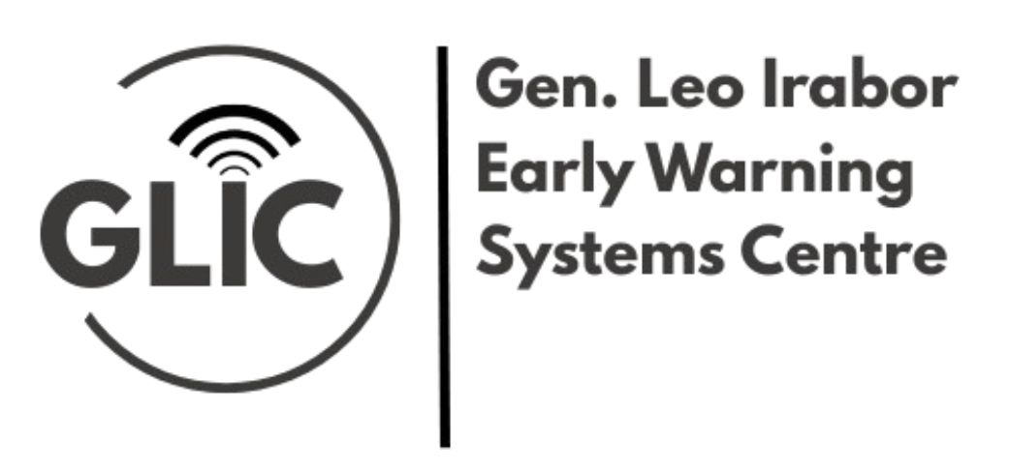    www.niia.gov.ng/early-warning-system-centre  earlywarning@niia.gov.ng | 13/15 Kofo Abayomi Road,    Victoria Island, Lagos  www.niia.gov.ng

